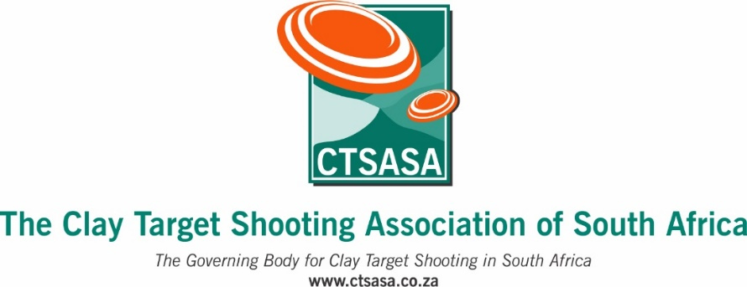

COMPETITION ENTRY FORM

CTSASA Olympic Trial-1 2026
Wattlespring Sport Shooting Club, near Bapsfontein
Entries close : Wednesday, 11th March 2026

Competition days : Saturday 13th and Sunday 14th March 2026

Please complete the following in full :
Full name and surname
CTSASA Number
Province
Email address
Cell number
Date of birth

Discipline/Event | Tick to select
Olympic Trap – 100 Targets Saturday
Olympic Trap – 100 Targets Sunday
Olympic Skeet - 100 Targets - Sat
Olympic Skeet - 100 Targets - Sun

ENTRY FEES :
Senior : R900 per 100 targets
Junior : R800 per 100 targets

Practice : R200 per 25 targets

ENTRIES AND PAYMENT :

BANK DETAILS : Name of account : Wattlespring Sport Shooting Club, Nedbank Current Account Number : 1229 145281, Branch Code : 198765

ENTRY FORM AND PROOF OF PAYMENT : Please send your entry form and proof of payment addressed to Adriaan Pienaar to info@wattlespring.co.za and copy in comps@wattlespring.co.za, using your name, CTSASA no. and OTT326 as the reference

