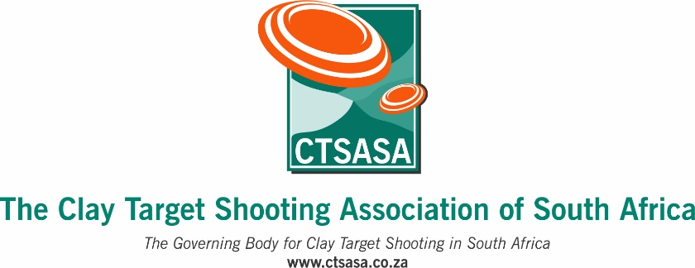

COMPETITION ENTRY FORM

CTSASA Eastern Cape English Sporting Championship 2026
Port Elizabeth Clay Target Club

Competition days : Saturday/Sunday 11th/12th April 2026
Enquiries: Zerelda Bester : 076 493 2817 : peclaytargetclub@gmail.com

Entries close : Wednesday, 8th April 2026

Please note:
* All CTSASA English Sporting Championships are shot over 200 targets
* All championships are National Trials if included in the current National Trial Period
* Please note that not all targets shot are for National Protea Trials - please check the National Trial regulations for each discipline. If in doubt, please email info@ctsasa.co.za for further assistance

Please complete the following in full :
Full name and surname
CTSASA Number
Province
Email address
Cell number
Date of birth

Discipline/Event | Tick to select
English Sporting – 200 targets – Saturday and Sunday
English Sporting – 100 targets only Saturday
English Sporting – 100 targets only Sunday
colt category - 100 targets – Saturday/Sunday, 50 per day

ENTRY FEES :

Senior - 200 targets - R1900.00 Senior - 100 targets - R950.00
Junior - 200 targets - R1900.00 Junior - 100 targets - R950.00
Practice fee : R165/25 targets

ENTRIES AND PAYMENT :

PLEASE EMAIL YOUR ENTRY TO : Zerelda Bester : peclaytargetclub@gmail.com

Name of account : Short Road Holdings PTY Ltd t/a Port Elizabeth Clay Target Club
Account Number : 109 853 0667 Branch Code : 113 717
Bank Name : Nedbank - Type of account : current account
Please put your NAME and CTSASA number, followed by ECSEP26 as the reference, thank you!
e.g. SAMUEL SMITH 1234 ECESP26

Please send your POP to Zerelda Bester : peclaytargetclub@gmail.com

